 SYSTEM
LOGIN SCREEN
The login Screen for Liberty is divided into Company authentication screen and user account authentication screen.
- The company authentication screen is available for company that subscribed for cloud services as shown below:

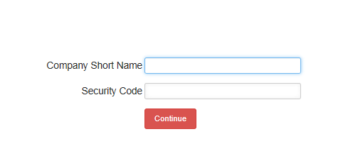
Company Short Name: This box accepts short name of user’s company made available by the system administrator.
Security Code: This box accepts a password code of user’s company also made available by system administrator. User press the continue button to proceed to user authentication screen
- The user account authentication screen is available for both cloud services subscriber and in-house installation services as shown below:
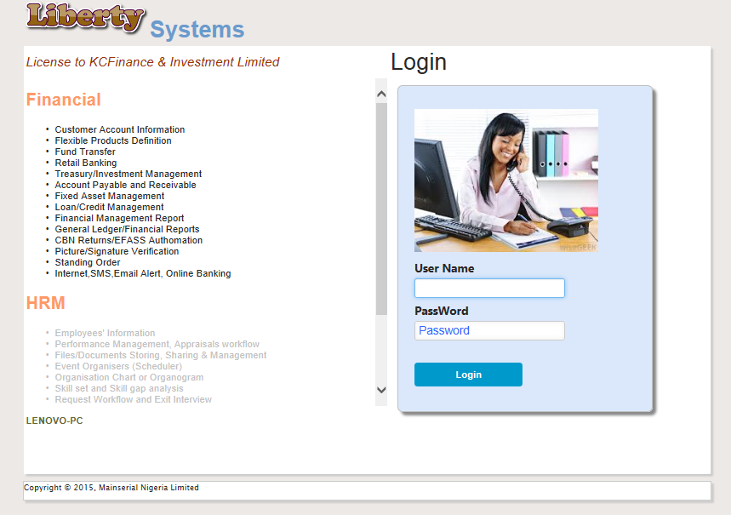
User Name: This box accepts user name as input from user.
Password: This box accepts password code from user. The two inputs will be validated when user press the login button. Note that user name and password of a user are made available to user by system administrator. After successful validation (authentication by clicking on Login button) the general user interface (GUI) of Liberty system will be displayed as shown in the next page.

The General User Interface of Liberty system
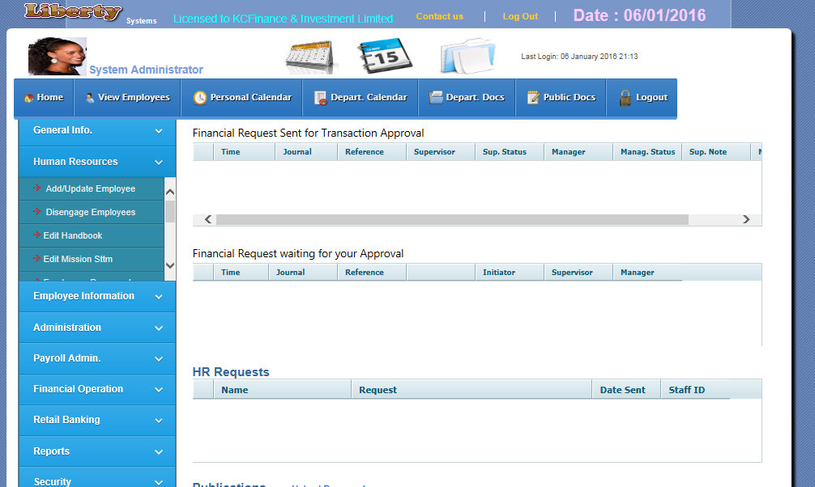
Upload documents
8
9
5
4
3
2
7
6
1

- Display User name and picture of current user: By clicking on user’s picture, new employee can be selected and the self-service functionalities of the system can be applied to newly selected employee. Note that this can only be performed by user account that has access to changing employee for administration
- Personal calendar for current user: This is a personal calendar for login user, it allows user to book and keep diary of events. Any event booked can only be viewed and edited by the user.
- Group or departmental calendar for current user: This is a group calendar for login user, it allows all users in a group to book and keep diary of events. Any event booked can only be viewed and edited by the group member.
- Organisation’s publications management: This is a file sharing functionality; it allows all employees to share documents by uploading such documents into Libertysystem for publications.
- Short cut menu bar: This menu bar allows quick access to some functionalities like:
- Home Page: This displays request from surbodinates/referrer and publications
- Search & View all employees: This allows user to search for employees and display their details
- Personal Calendar: For managing user’s diary of events
- Departmental Calendar: For managing group of users diary of events
- Departmental Documents : for sharing documents among group members
- Logout: To exit from HRM system
- Panel menu bar: This is the main menu bar of the system; it contains menu items for group of functionalities. The menu items are :
- General Info.
- Human Resources
- Employee Information
- Administration
- Payroll Admin
- Reports
- Security
- Performance Management
- Panel Submenu: This is a submenu to each of the items in panel menu bar. Each of the submenus represents functionality in the system.
- Display of requests from surbodinate or referrers
- Display of Organisation’s publications

Setups and Configurations
Before Liberty system can be put into use in an organization, some basic rules have to be done within the system. Some of these basic rules are:
- Setups
- Company: To setup the company name, navigate to Administration panel bar menu, then select company menu.
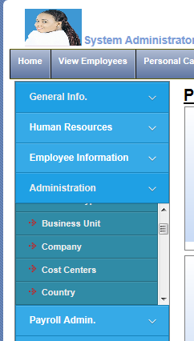
Click on this button to upload logo picture
Company Logo
Company name
Company setup menu
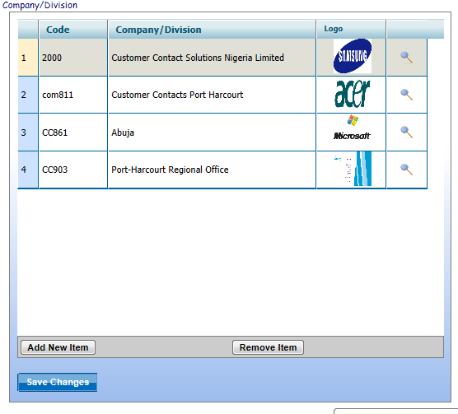
Click on this button to remove selected company
Click on this button to add more companies

- Department: To setup the department names, navigate to Administration panel bar menu, then select Department menu.
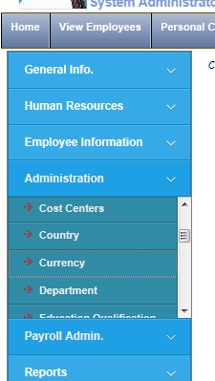
Click on this button to remove selected department row from the list
Click on this button to add new department row to the list
Enter or update department name in the list
Department setup menu
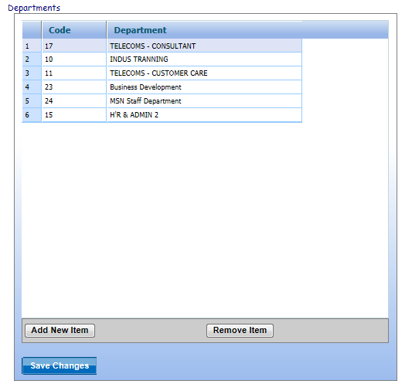
Click on save changes button to update the system with changes made to department list

- Skill Category: This is grouping of employees’ skill set. To setup or predefine the Skill Category, navigate to Administration panel bar menu, then select Skill Categories menu.
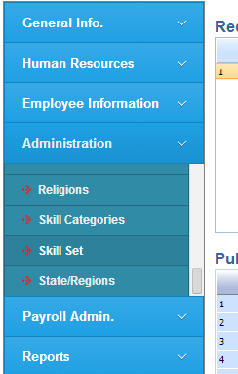
Click on this button to add new skill category to the list
Enter or update skill category in the list
Skill Categories menu
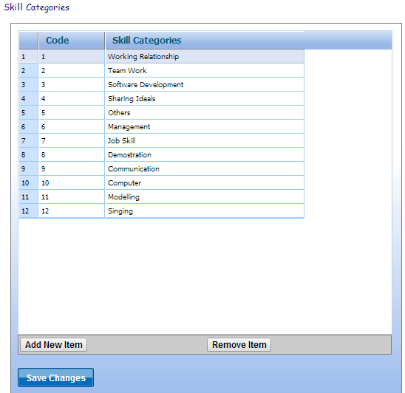
Click on save changes button to update the system with changes made to skill category list
Click on this button to remove selected category from the list

- Skill Set: To setup or predefine the Skill set , navigate to Administration panel bar menu, then select Skill Set menu.
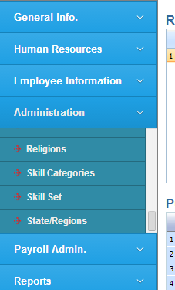
Enter cost of training
Enter training required for the skill
Enter or update skill in the list
Select skill category for the skill
Skill Set menu
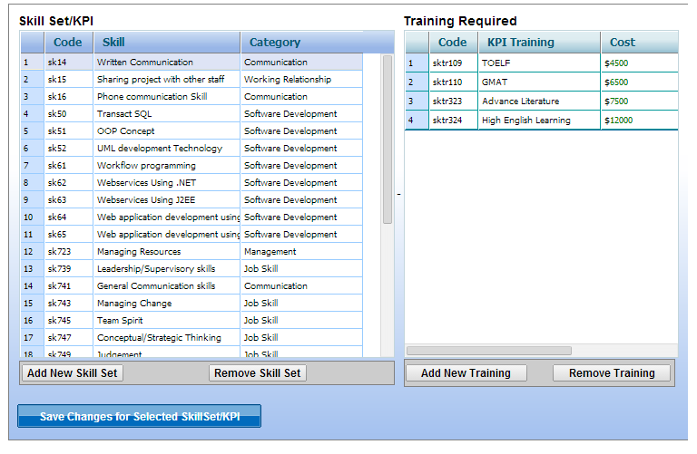
Click on save changes button to update the system with changes made to skill and training required list. Remember to always save each skill updated or entered before updating another one
Click on this button to remove training from the list
Click on this button to remove skill from the list
Click on this button to add new training to the list
Click on this button to add new skill to the list

- Employee positions: To setup the positions or grades, navigate to Administration panel bar menu, then select positions menu.
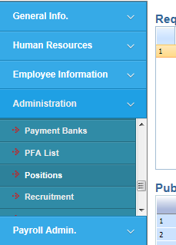
Positions setup menu
Select reporting to position
Enter or update position/Grade name in the list
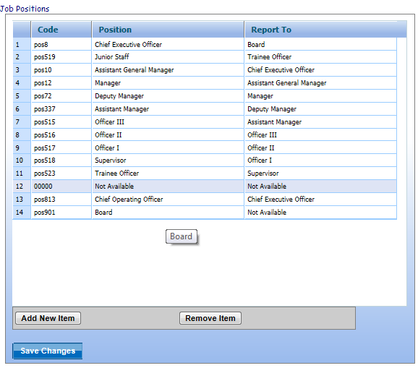
Click on save changes button to update the system with changes made to position list
Click on this button to remove selected position row from the list
Click on this button to add new position row to the list

- Employee job titles: To setup or update the job titles, navigate to Administration panel bar menu, then select job titles.
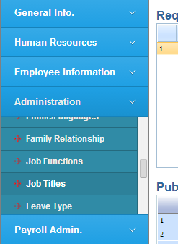
Select the job title is reporting to
Employee job titles setup menu
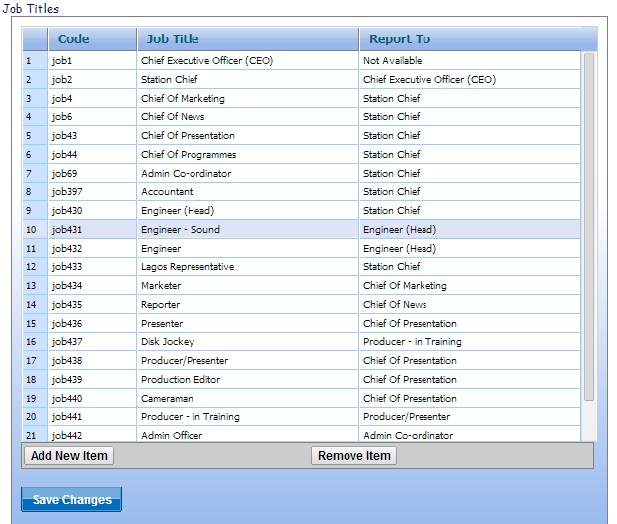
Click on save changes button to update the system with changes made to job title list
Click on this button to remove selected job title row from the list
Click on this button to add new job title row to the list
Enter or update Job title name in the list

- Employee Positions and job titles mapping (Job function): The mapping of positions/grades to its corresponding job titles in the HRM system produce job function. This can be achieve by navigating to Administration panel bar menu and select job Functions
Job Function setup menu
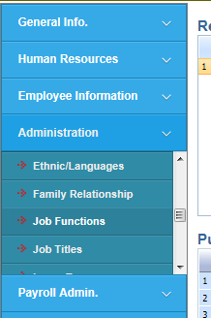
Skill Set required for job function jk530
Job title selected and mapped to grade/position for jk530
Salary entered for job function jk530
Job function with code jk530 selected
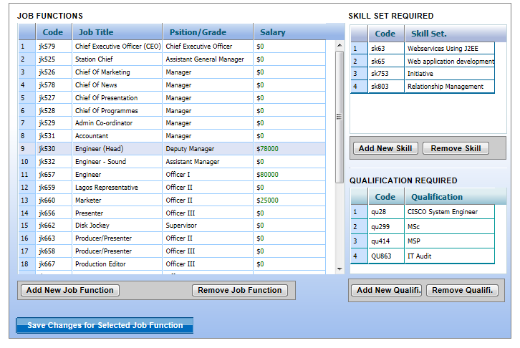
Press this button to remove selected Qualification from the list
Press this button to add new job function
Grade/Position mapped to Job title for jk530
Education qualification required for job function jk530
Press this button to remove selected skill set from the list
Press this button to add more required Skill Set for job function jk530

Press this button to save and update the system for selected job function
Press this button to remove selected job function from the list
Press this button to add more required qualification for job function jk530
- Employment type: To setup or update employment types in the HRM system, navigate to Administration panel bar menu, then select Employment Types.
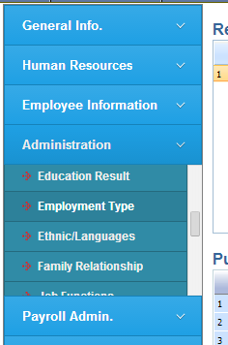
Click on this button to remove selected employment type from the list
Enter or update employment type in the list
Employment type setup menu
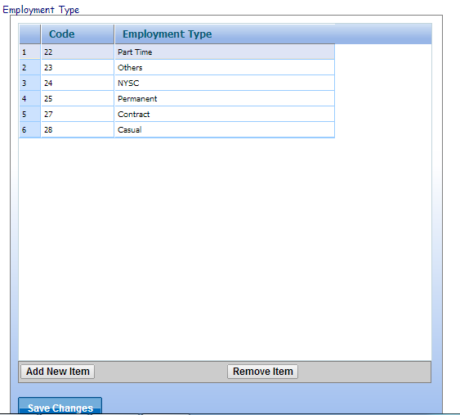
Click on save changes button to update the system with changes made to employment type list
Click on this button to add new employment type to the list
- Others but not compulsory setups are Absence Types, Activity Types, Address Types, Business Unit, Cost Centers, Country, Currency, Education Qualification, Education Result, Ethnic/Language, Family Relationship, Leave type, Loan type, Payment Banks, PFA List, Religious, Skill Categories, Skill Set, State/Regions etc.

- Configurations: To open the configuration settings screen, on HRM system navigate to Security Menu panel, expand it to see the sub menu then click on configuration settings.

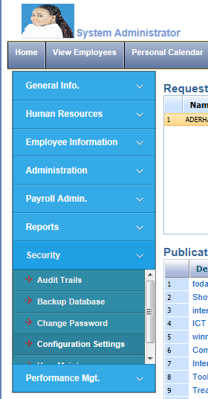
Configuration settings: This is a configuration setting menu, click on this menu to open the screen as shown in the next page

Configurations
Auto Generate Staff No: By toggling this button to Yes or No, the system can be forced or dis-enforced respectively to automatically generate Staff number
Use Company Prefix for staff No: This is an option button that enforced or dis-enforced the use of company prefix when adding new employee to the system. By toggling on the button, company prefix can be enforced or dis-enforced by setting it to Yes or No respectively.
Company Prefix: This is a prefix word for company name, is usually appended to Staff No/Employee number when adding new employee to the system. For this tutorial the prefix entered is MSN
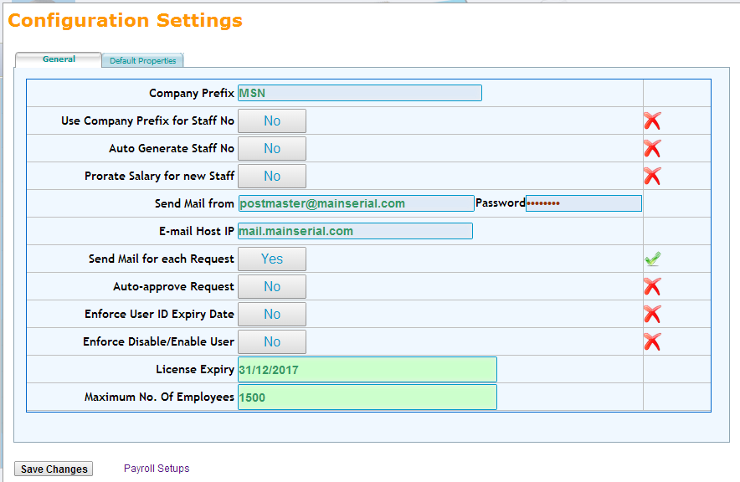
Send mail for each request: This option enforced or dis-enforced sending of mail for each request made by user. Is set to yes, mean that e-mail will be sent for all requests made by users
Auto approve request: If this toggle button is set to yes, all requests will not be submitted to supervisor for approval, otherwise if set to No, they will pass through approval by supervisors
Send mail from: This is sender e-mail address for all outgoing e-mail sent from HRM system. The e-mail is authenticated if password is provided otherwise not authenticated before sending mail
E-mail Host IP: This is Outgoing e-mail server Name or IP address
Prorate Salary: This Yes/No toggle button enables new employee salary to be prorated if set to Yes.

Enforce User ID Expiry date: This option if set to Yes tells the HRM system to check if user account has expired, then deny such user entry into the system when Logging Into the system
Enforce Disable/Enable: This option if set to Yes tells the HRM system to check if user account has been disabled by administrator, then deny such user entry into the system when Logging Into the system

License Expiry Date: Display the next expiry/Renewal date for users/Company’s license, based on the business terms of agreement
Maximum No. of employees: This displays the maximum number of employees that can be added to the HRM system, again this depend on business terms of agreement
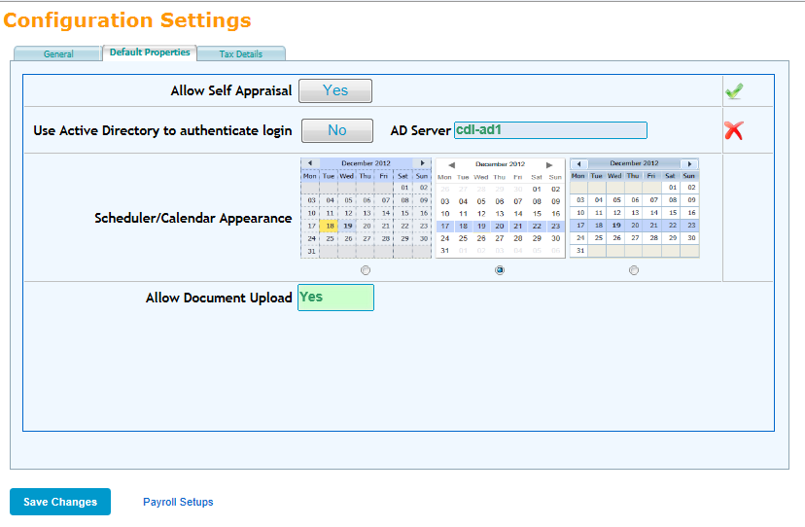
Allow document Upload: This indicator shows whether the system allow (Yes) or not allow (No) documents to be uploaded into the system via document management interface.
Scheduler/Calendar Appearance: This radio button list set the appearance or skin of calendar
Use Active Directory to authenticate Login: This Yes/No toggle button enables user to be authenticated with Network active directory when logging in if set to Yes and AD server specified.
Allow Self Appraisal: This Yes/No toggle button enables employee to appraise himself/herself in performance management if set to Yes.

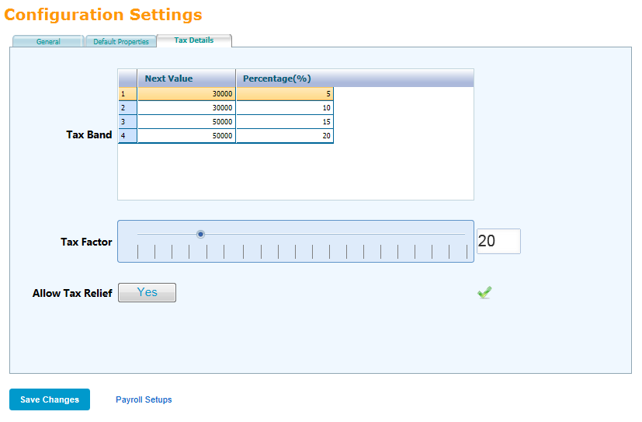
Allow Tax Relief: This Yes/No toggle button enables employee to enjoy tax relief based on number of children and dependants if set to Yes.
Tax Factor: Threshold setting for calculated PAYE tax, this can be adjusted by moving the slider to desired value
Tax Band: Detail tax band for PAYE tax
After setting all the necessary values, click on save changes button to update the system.

- Payroll Setups: To open the payroll setups screen, on HRM system navigate to Payroll Admin Menu panel, expand it to see the sub menu then click on Payroll Options

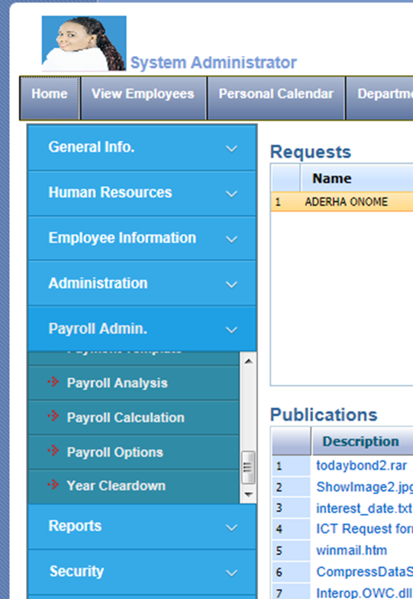
Payroll Options: This is a payroll setups menu, click on this menu to open the screen as shown in the next page

Total number of working weeks in a year
Daily working hours
Monthly Working Days: This is average working days in a month
Payroll company name
Number of times interest is compounded in a year, this is make use of when calculating loan with compound interest

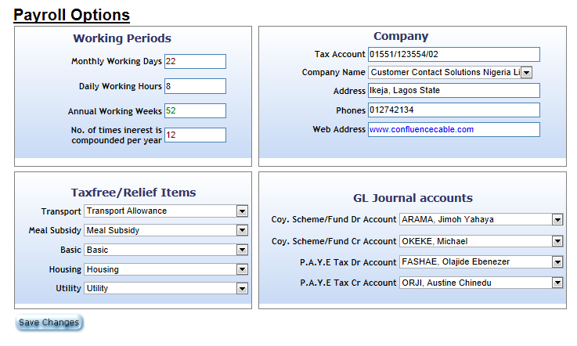
Tax Relief Payment variables (Payitem)
GL journal accounts for Scheme/Fund like Pension payments and PAYE tax for employees

Click on save changes button to update the system for all values

How to Add Employee to Liberty System
To add new employee to the HRM system, use the following steps:
- Login to the HRM system with administrator’s user account
- Create user account for the employee if the employee will be allowed to use HRM system and the user account is not to be automatically created by the system. To create user account manually, navigate to security menu item in Panel menu bar, Click on it to expand, Select user maintenance submenu.
- 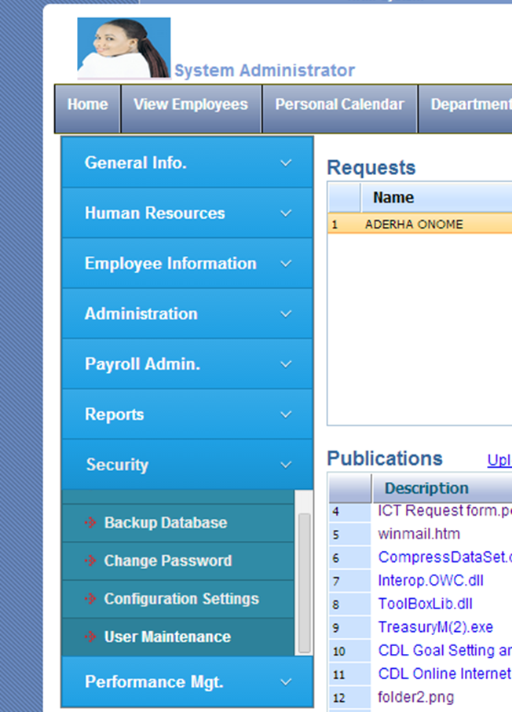
Click on User Maintenance under security group menu
The user maintenance screen appears; select the group name for the user. You can equally create new group. For this purpose we select Account Unit group as shown below:
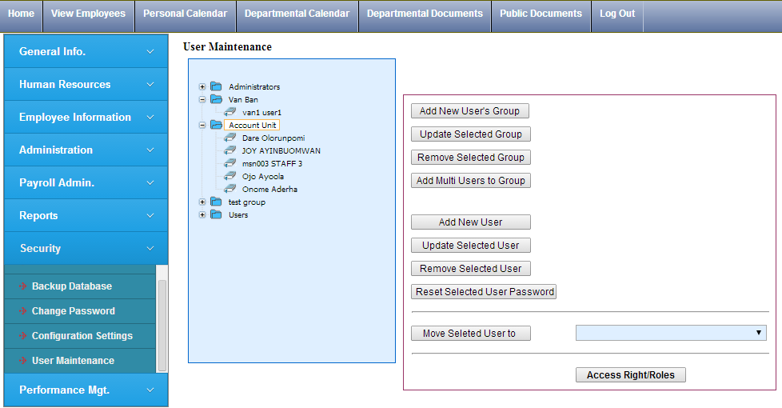
Click on Add New User button to create this new user
Account Unit selected as a group for the new user to be created
After clicking on Add new User button, the system allows user to inputs the following variables:
Supervisor: Employee ‘s reporting supervisor
User ID: This accepts username input; in this case the username is tbolade
Full Name: This accepts fullname of the new user we are creating and for this purpose we enter Tayoni Bolade
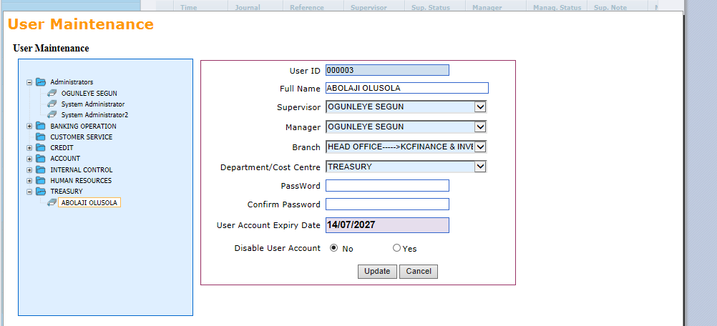
Department: Employee’s department in brach
Supervisor: Employee’s office branch/Unit
Manager: Employee’s reporting manager
Password: This accepts password code input
Disable user account: This enables this user account to be disabled or enabled by selecting yes or no option respectively
Confirm password: This accepts confirmation of password code inputed

User account expiry date: This accepts the expiry date for this user account

After all the inputs, click on add button to finally create the user account or cancel button to discontinue the creation. For the purpose of this tutorial we click on add to create this user under Account Unit group as shown below.
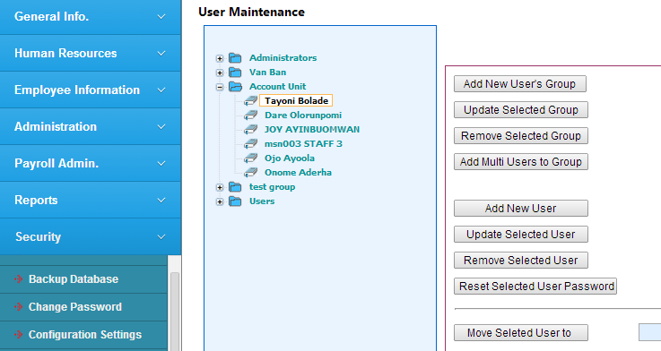

- Add new or update existing employee: Click on Human Resources menu panel to expand it, select add/update employee menu item as shown below
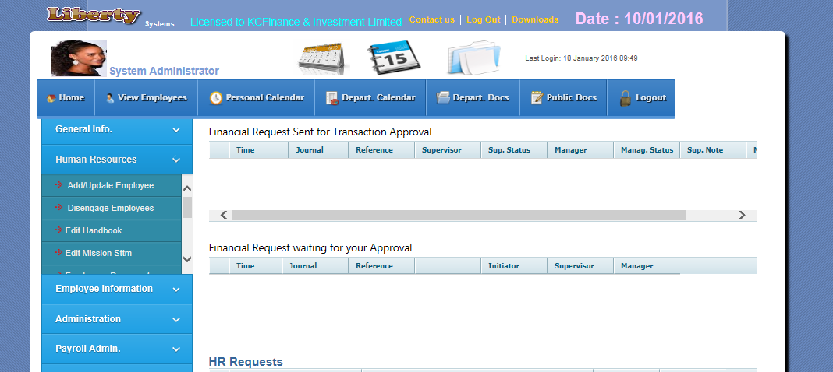
Staff Number: Enter employee number into this input box, and then click on ok button, all information about employee will be displayed if such employee is existing in the system
Add /update employee: Click to select page to add new employee or update information for existing employee
After making all inputs for the affected employee, click on save data button to update
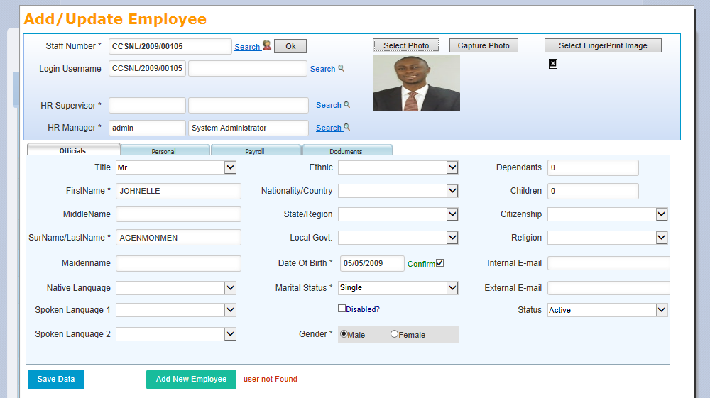
Capture photo: Click on the button to capture picture with system cameral to upload for the employee
Select photo: Click on the button to upload employee picture
Search: Click on the link to search through the list of existing employees in the system

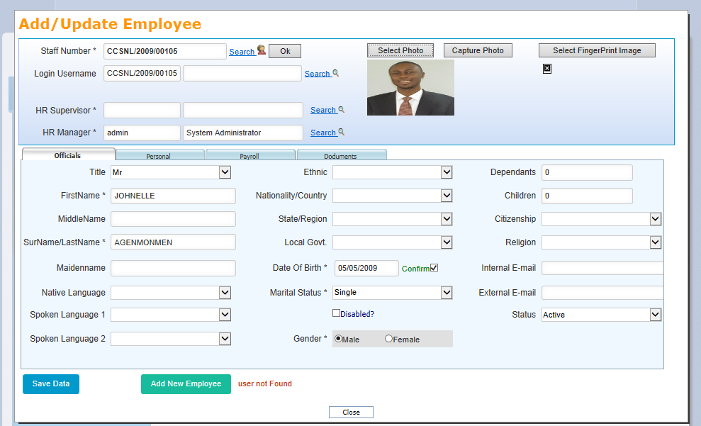
Personal Tab: All other Biodata and official data are contains in this tab, all inputs mark with * are mandatory/Compulsory
Official Tab: All Biodata are contains in this tab, all inputs mark with * are mandatory/Compulsory
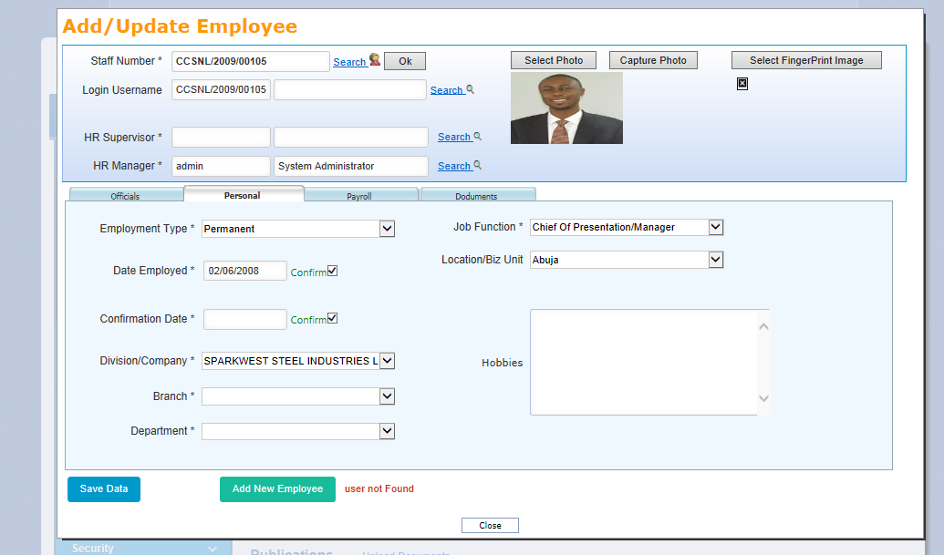

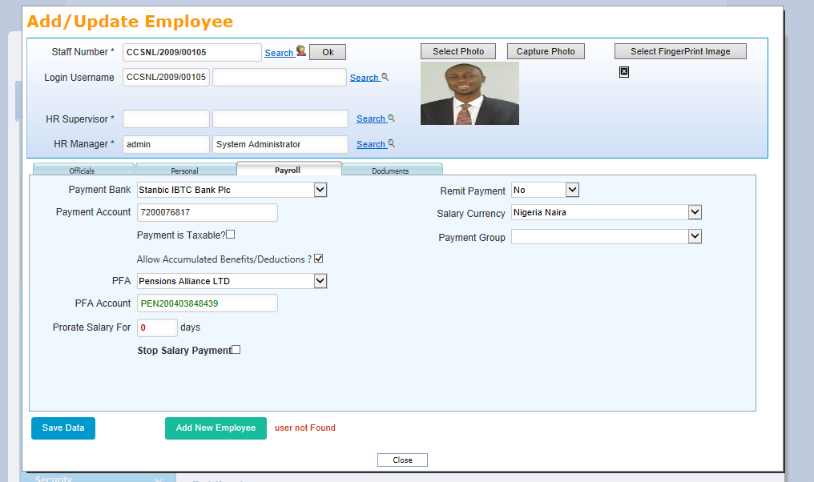
Documents Tab: All uploaded documents for the selected employee are contains in this tab, all inputs mark with * are mandatory/Compulsory
Payroll Tab: Selected employee Payroll parameter data are contains in this tab, all inputs mark with * are mandatory/Compulsory
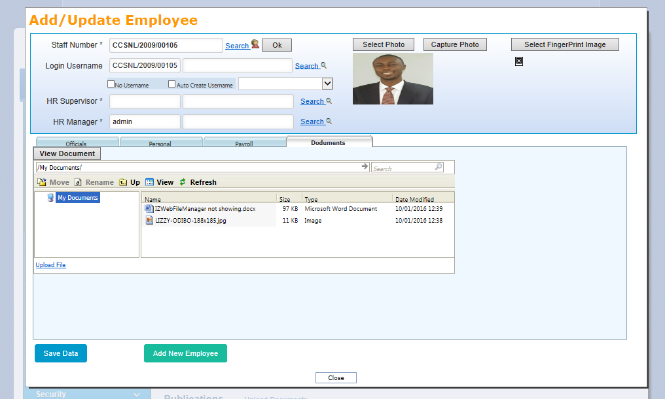
Close: Click on this button to close the page
Add new Employee: Click on this button to add new employee into the system
Save Data: Click on this button to save all inputted data

How to Add/Update Employee payroll data in Liberty System
Payroll Admin: Payroll menu panel to update all payroll data
Login into the system, click on Payroll Admin menu panel to expand
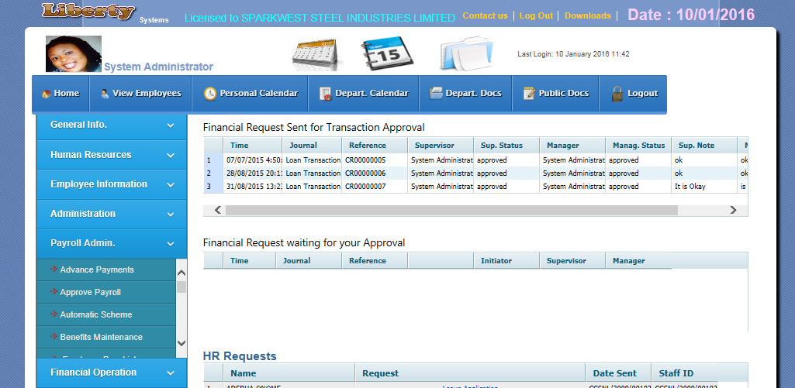
ID: Enter Staff Number of employee to be updated and leave the input box, current pay values attached to this employee will be displayed
Search image: Click on the image to search for employee in the system
To add or update employee payment values select employee payments page,
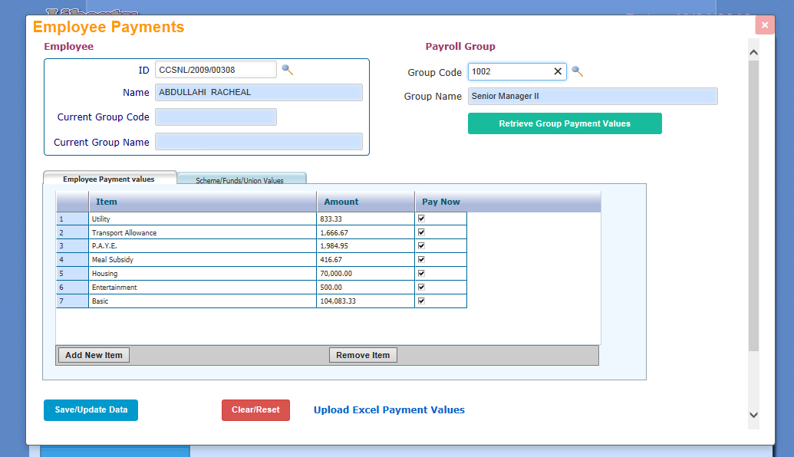
Amount: This column display payment item values and allows user to enter payment values against selected payment item
Add new item: Click on this button to add new default payment item
Search image: Click on this button to remove selected payment item
Pay Now: This column allows user to suspend payment values, if marked, such pay values will be paid but unmarked mean it should be suspended for the employee
Item: This column displayed the description of selected pay item and allows user to select pay item
Employee Payment values tab: This tab displayed the current default values for selected employee
Search image: Click on the image to search for employee in the system

The Payment items updated above (previous page) are those items that belong to deduction and allowance pay items but are not scheme items, not advance items and not overtime items. To update scheme values, open the scheme tab as shown below.
Payroll Group: default payment values and scheme can be updated directly from payroll group entered or selected into this input box
Scheme Payment values tab: This tab displayed the current scheme values for selected employee, scheme items are permanent contribution by employee and in some cases including contribution by employer on behalf of employee periodically, examples are Union due, PFA, Cooperative, housing Funds etc.
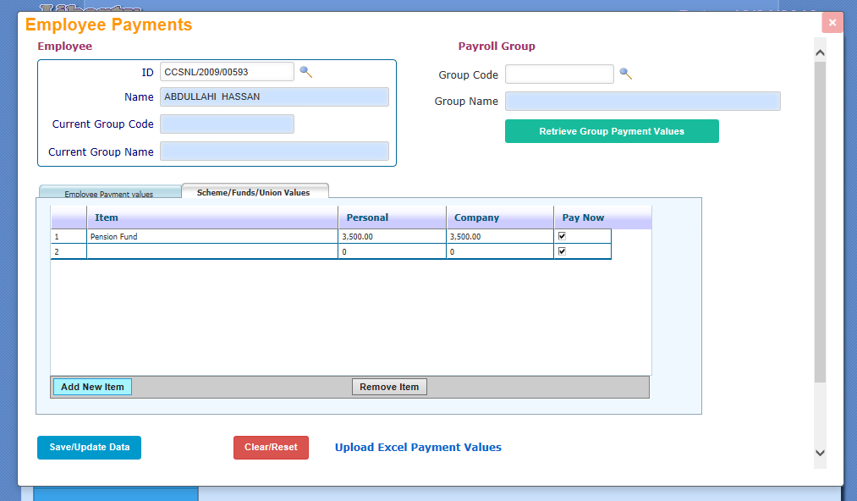
company: This displayed and allows user to input employer contribution for selected employee
Personal: This displayed and allows user to input personal contribution by selected employee
Retrieve group payment values: Click on this button to update selected employee payment values from his payroll group values and automatically attach that payroll group to the employee

Clear/Reset: Click on this button to clear the page for new input for another employee
Item: This column displayed the description of selected pay item and allows user to select pay item

Pay Now: This column allows user to suspend payment values, if marked, such pay values will be paid but unmarked mean it should be suspended for the employee

Upload Excel Payment values: This link open page for user to upload all type of payment item values except overtime payment item values for multiple employees at a time using Microsoft Excel Sheet

Save/Update data: Click on this button to save all updated default values and scheme values

To upload all type of payment item values except overtime payment item values for multiple employees at a time, click on Upload Excel Payment values link shown in previous page or click on Upload Payments menu item as shown below
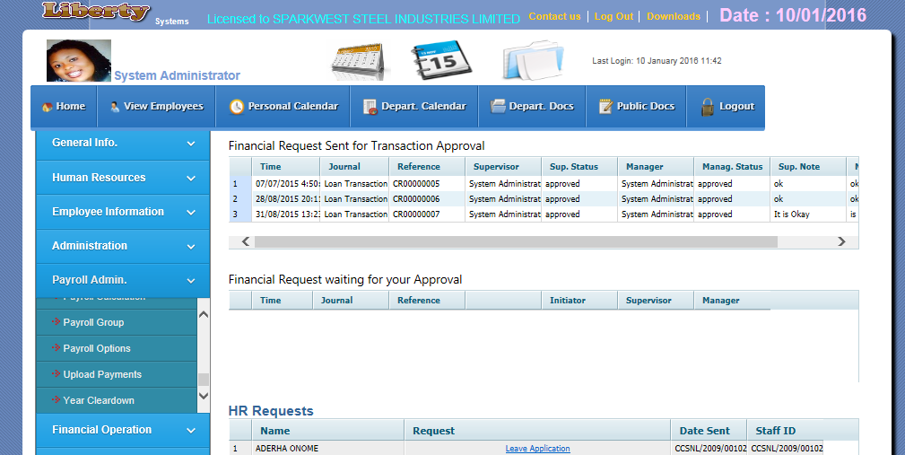
Load Content: Click on this button to display the content of the file in table
Upload File: Click on this button to get the excel file from your system
Upload Payments: This menu item open page for user to upload all type of payment item values except overtime payment item values for multiple employees at a time using Microsoft Excel Sheet

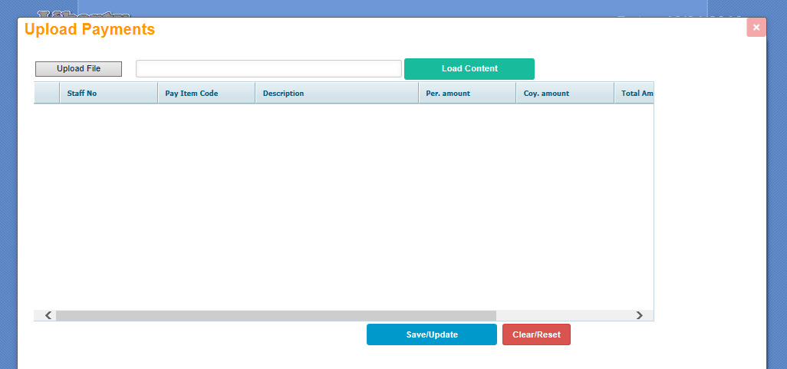
Coy. Amount: Column that display employer contribution for scheme/contribution
Per. Amount: Column that display amount for that payment item, in case of scheme/contribution it represents employee contribution
Description: Column that display the description of payment item as loaded from excel file
Pay item code: Column that display code of payment item, all payment items in the system have their unique code as define during setup
Staff no: Column that display staff number as loaded from excel file
Clear/Reset: Click on this button to prepare the page for new upload
Save/Update: Click on this button to save the displayed uploaded payment values

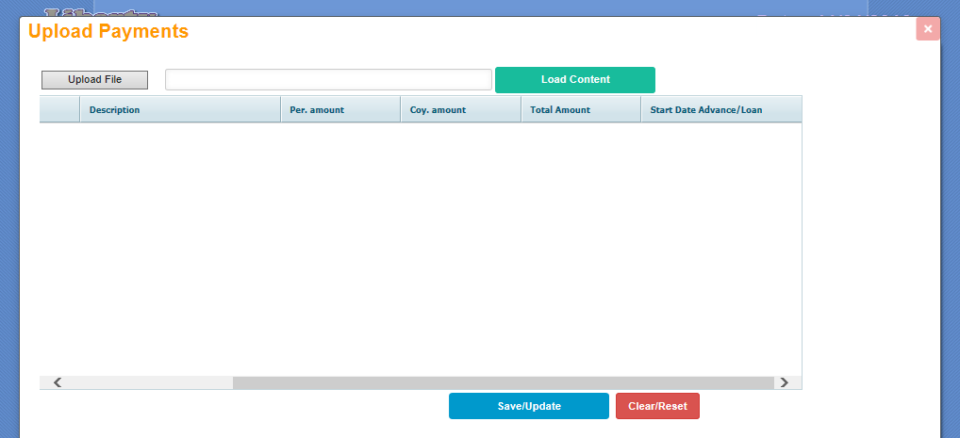
Total Amount Column that display the total or cumulative amount to be paid as allowance or deducted , this applied to advance/loan payment item, for example if per. Amount column has 500 and Total Amount Column has 2000, 500 will be paid monthly in 4 months to the employee in case of allowance and deducted monthly for 4 months in case of deduction

Start Date Advance/Loan Column that display the commencement date for the payment or deduction of amount specified, this applied to advance/loan payment item,

Sample excel files uploaded
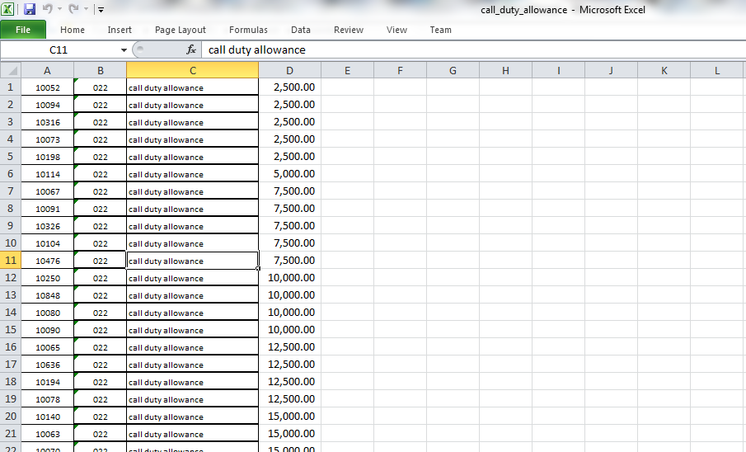
The above excel displayed below after uploading
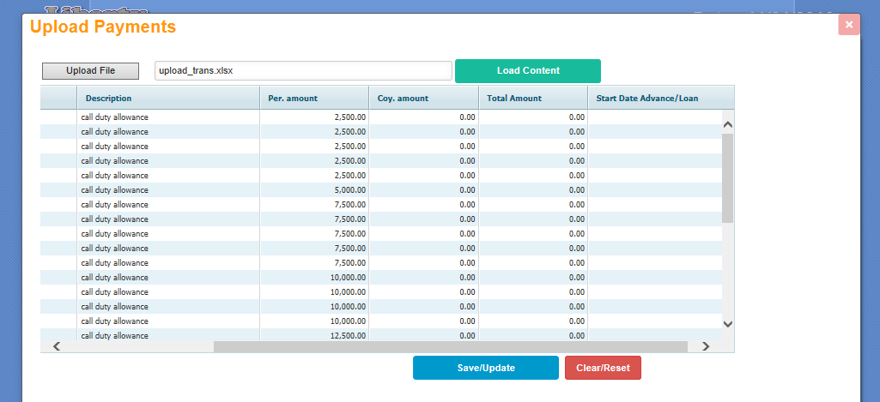

Sample excel files uploaded
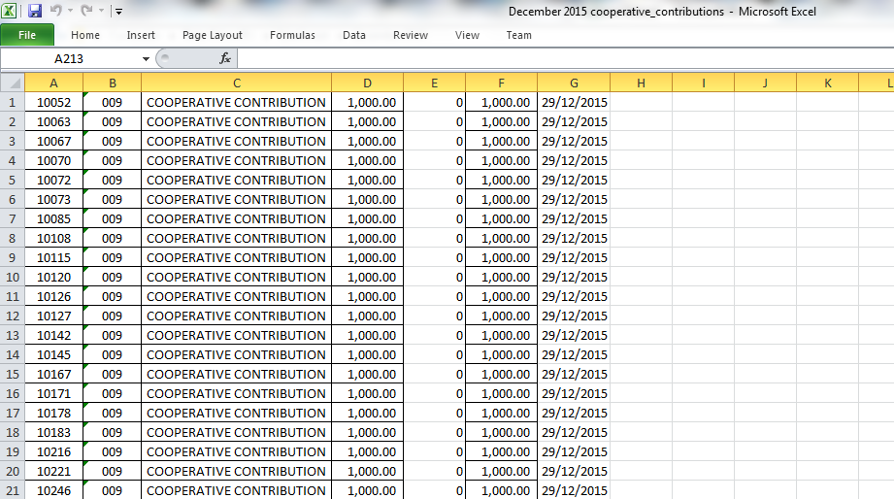
The above excel displayed below after uploading, you can see that contributing amount is the same as total amount, it means the contribution will only be effected just in one month
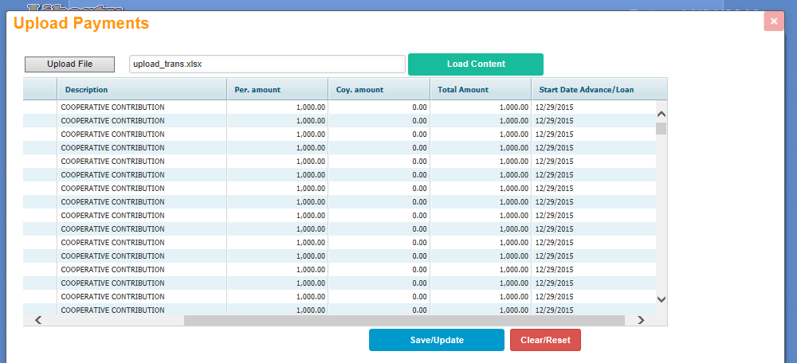

Sample excel files uploaded
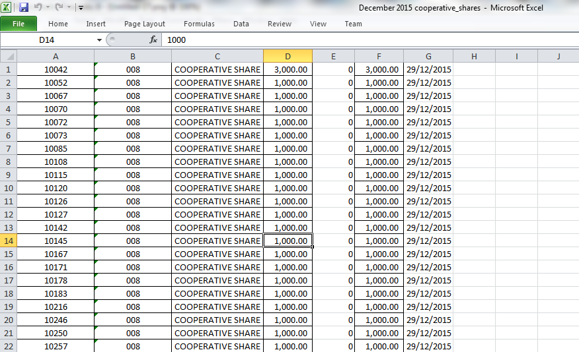
The above excel displayed below after uploading
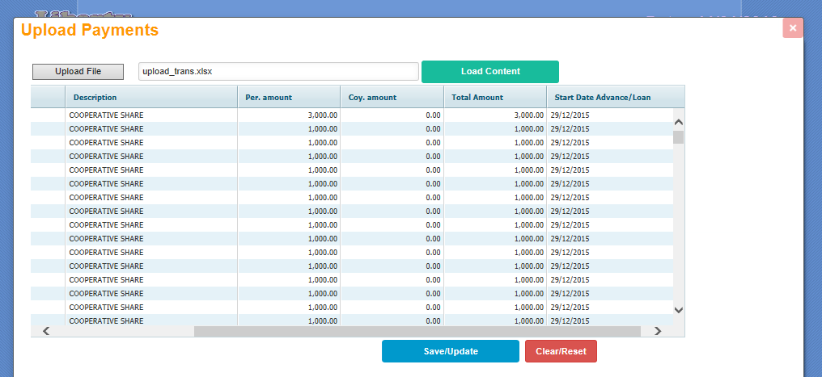

To Add or Update overtime values for employee
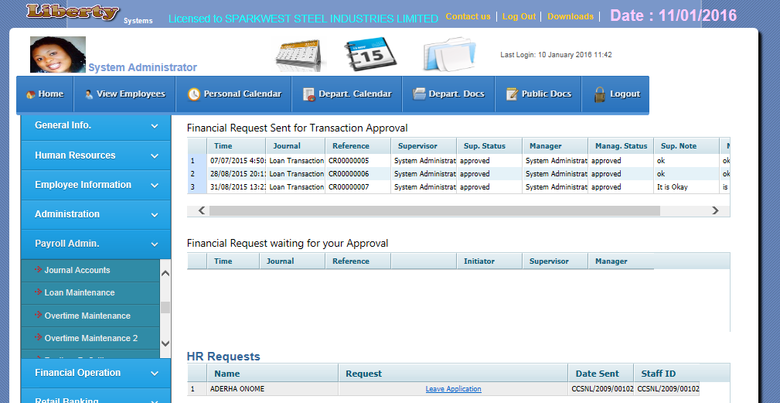
Payroll group: list of payroll group, if one or more group on the list is/are marked and checkbox save/update data for selected groups is also marked; employees that belong to affected groups will also be updated for the overtime payment values
ID: Staff number of selected employee
Overtime maintenance 2: click on this menu item to add or update employees’ overtime payment values
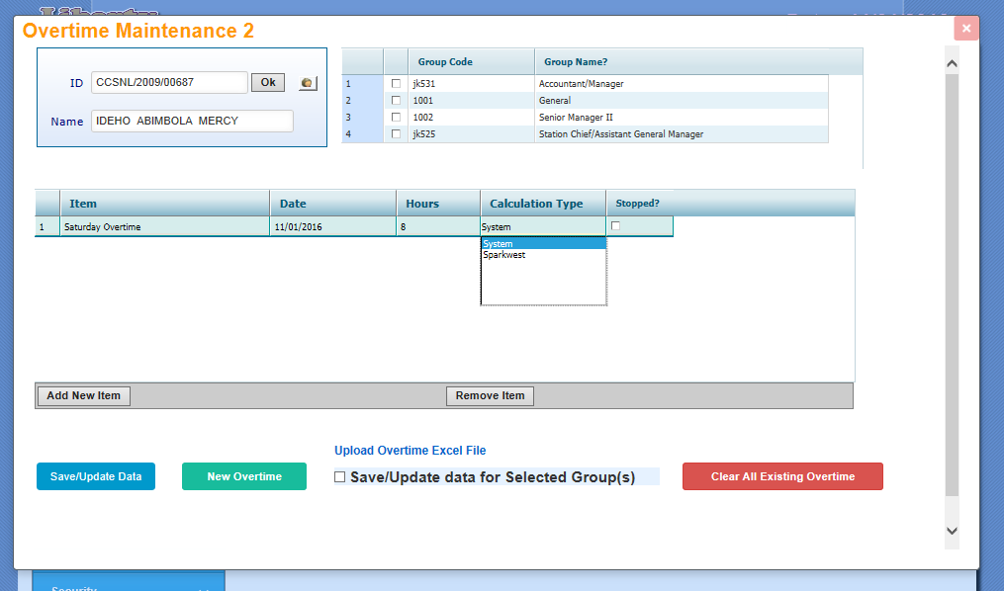
Upload Overtime Excel File: This link allows user to upload multiple overtime for employees using Microsoft excel file
Date: This column displayed and allows user to enter or select the date the overtime was done
Calculation type: the calculation method to use, system make use of work rate per hour as defined in the system, sparkwest is method customized for sparkwest steel industry. More customization can be added
Item: This column displayed the description of selected overtime payment item and also allows user to select payment item

Stopped: This stopped payment for the overtime if marked
hours: This column displayed and allows user to enter hours spent for the overtime

To upload overtime values using excel
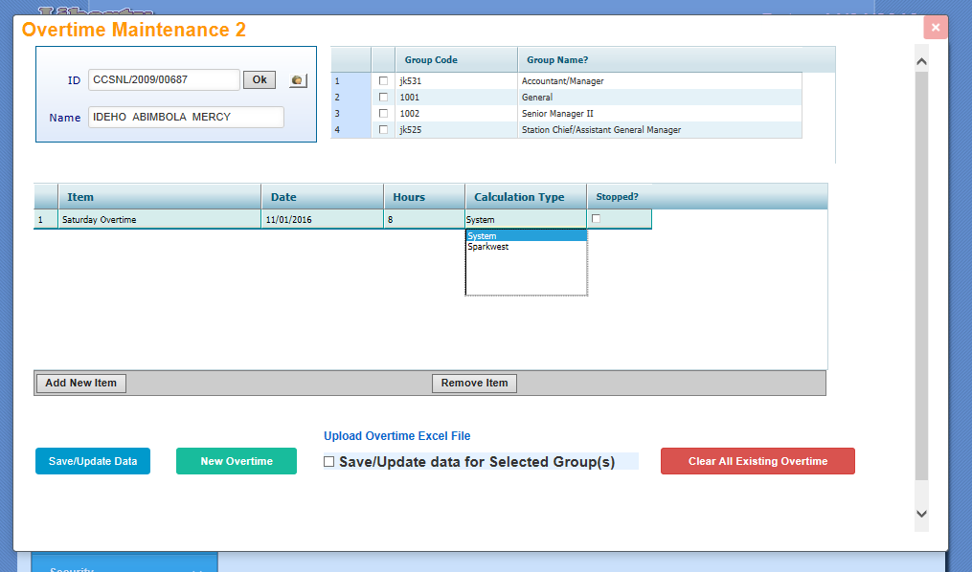
Upload Overtime Excel File: click on this link to open page to upload multiple overtime for employees using Microsoft excel file
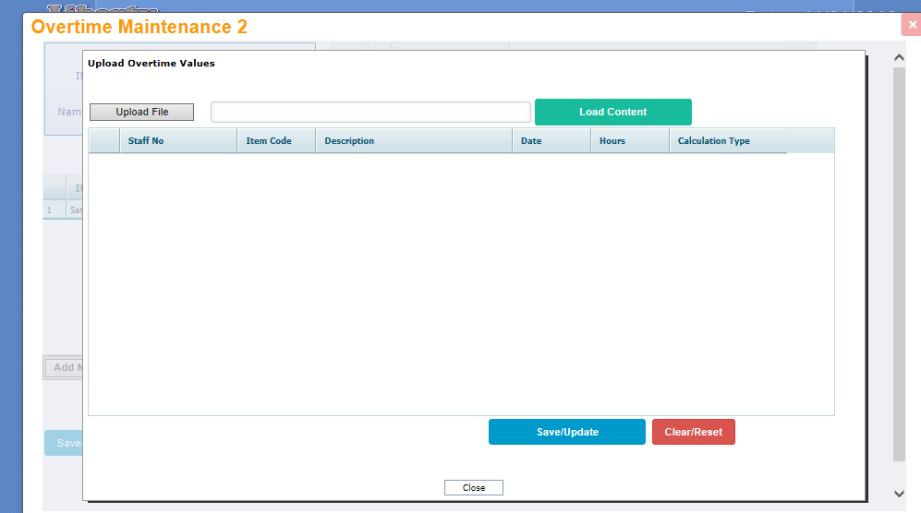

Sample overtime excel file
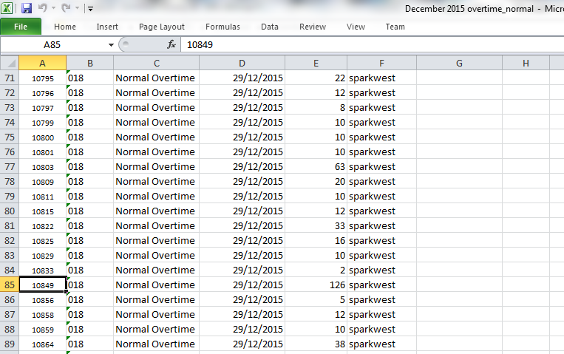
The above excel displayed below after uploading
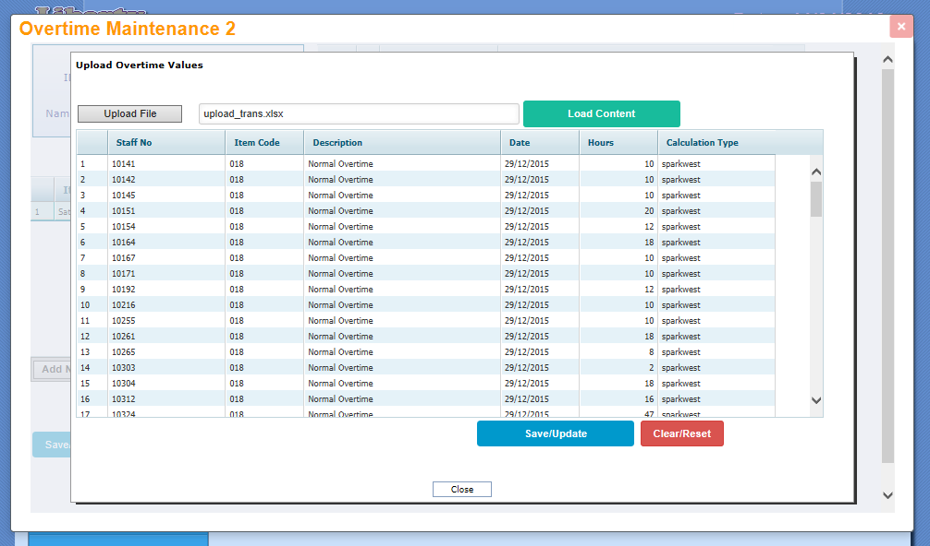
Sample overtime excel file
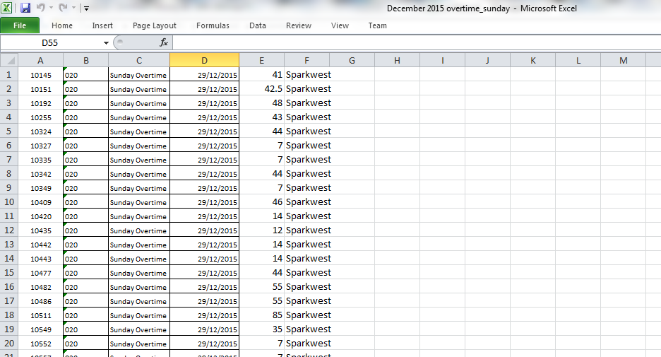
The above excel displayed below after uploading
